To get local copy.

1. After conflict for sync…
2. Git reset –hard
3. Git push –force

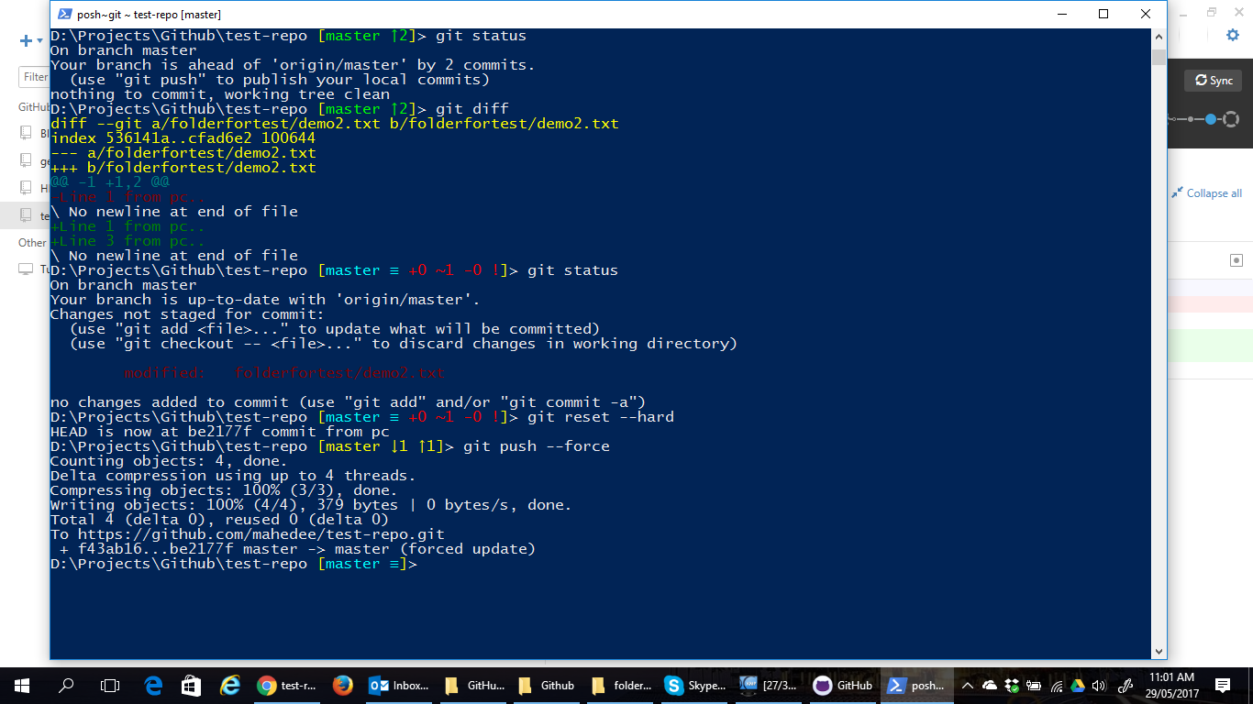

Add git ignore

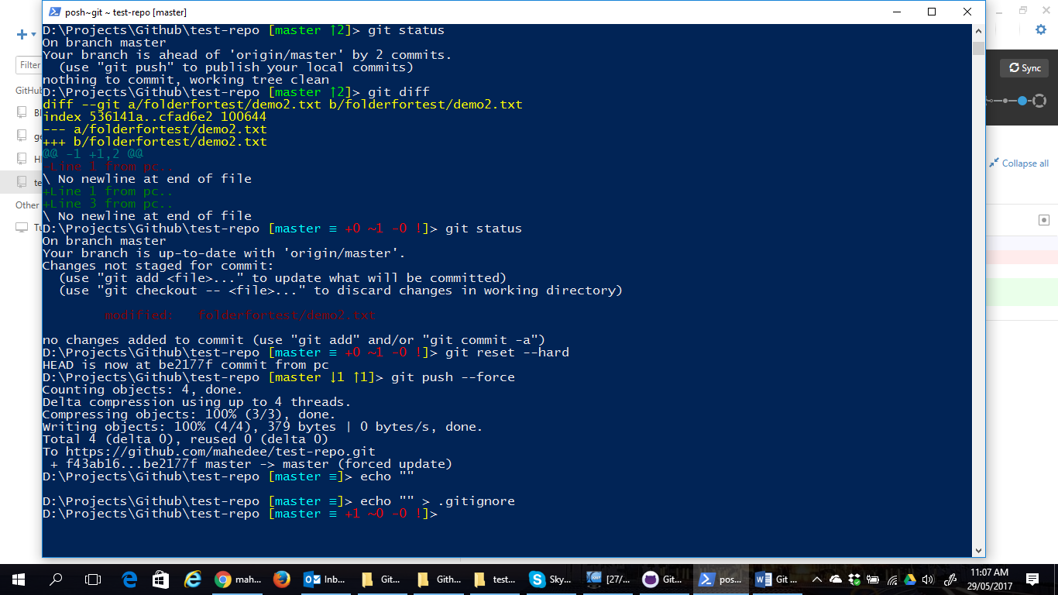

Cloning, push, pull

